- What is JavaScript?
JavaScript is a scripting language used for both client and server-side development. It enables developers to create interactive web pages.
In other words, JavaScript is a text-based method that allows the developer to create dynamically updating content, control the multimedia, or we can animate the images, etc.
- JavaScript Features
JavaScript is a highly popular and widely-used programming language for web development. It has a variety of features that make it powerful and flexible. Some of these features include being dynamic, lightweight, interpreted, functional, and object-oriented.
Many open-source JavaScript libraries are available, facilitating the utilization of JavaScript in both frontend as well as backend development. Let's highlight some of the key features of JavaScript.
- Easy Setup
We dont need a particular editor to start writing the JavaScript code. Even anyone can write JavaScript code in NotePad. Also, JavaScript can be executed in the browser without any interpreter or compiler setup.
You can use the <script > tag to add JavaScript in the HTML file. However, it also allows you to add JavaScript to the web page from the external JavaScript file, having '.js' extension.
- Browser Support
All browsers support JavaScript, as all modern browser comes with the built-in JavaScript execution environment.
However, you can also use the window object to check whether the browser supports JavaScript or its particular feature.
- Dom Manipulation
JavaScript allows developers to manipulate the webpage elements. Also, you can control the browser.
It contains the various methods to access the DOM elements using different attributes and allows to customize the HTML elements.
- Event Handling
JavaScript allows you to handle the events used to interact with the web page.
For example, you can detect the mouse click on a particular HTML element using JavaScript and interact with the HTML element.
Some other events also exist, like detecting the scrolling behavior of web page, etc. We will explore all events in the JavaScript events chapter.
- Dynamic Typing
JavaScript decides the type of variables at runtime. So, we dont need to care about variable data type while writing the code, providing more flexibility to write code.
Also, you can assign the values of the different data types to a single variable. For example, if you have stored the number value of a particular variable, you can update the variables value with the string.
- Functional Programming
JavaScript supports the functional programming. In JavaScript, you can define the first-class function, pure functions, closures, higher-order functions, arrow funcitons, function expresions, etc.
It mostly uses the functions as a primary building blocks to solve the problem.
- Cross-platform Support
Each operating system and browser support JavaScript. So, it is widely used for developing websites, mobile applications, games, desktop applications, etc.
- Object-oriented Programming
JavaScript contains the classes, and we can implement all object-oriented programming concepts using its functionality.
It also supports inheritance, abstraction, polymorphism, encapsulation, etc, concepts of Object-oriented programming.
- Built-in Objects
JavaScript contains built-in objects like Math and Date. We can use a Math object to perform mathematical operations and a Date object to manipulate the date easily.
However, you can also manipulate the functionality of the built-in object.
- Object Prototypes
In JavaScript, everything is an object. For example, array, function, number, string, boolean, set, map, etc. are objects.
Each object contains the prototype property, which is hidden. You can use the prototype property to achive inheritance or extend the functionality of class or object, by other objects functionality.
- Global Object
JavaScript contains the global object to access the variables which are available everywhere.
To access global variables in the browser, you can use the window object, and in Node.js, you can use the 'global' keyword to access global variables.
- Built-in Methods
JavaScript also contains the built-in methods for each object. Developers can use the built-in methods to write efficient and shorter codes.
For example, the Array object contains the filter() method to filter array elements and the sort() method to sort the array. The String object contains the replace() method to replace text in the string, the trim() method to remove whitespaces from the string, etc.
- Modular Programming
JavaScript allows you to write the code in different modules and connect them with the parent module. So developers can write maintainable code.
By writing the code in a separate module, you can reduce the complexity of the code and reuse each module whenever you require.
- JSON
JSON stands for JavaScript object notation. It is a widely used data format to exchange data between two networks. For example, server and client.
JavaScript also supports the JSON format to store the data.
- Asynchronous Programming
JavaScript is a single-threaded programming language. To execute your code faster, you can use asynchronous programming.
You can use promises in JavaScript to write asynchronous code, allowing us to handle multiple tasks asynchronously.
- Event-driven Architecture
The event-driven architecture of JavaScript allows developers to create interactive and responsive web applications by handling a large user base concurrently.
Due to the vast features and applications of JavaScript, the front end of Facebook is built on JavaScript. Netflix is built using the ReactJS framework of JavaScript. Similarly, Amazon, PayPal, Airbnb, LinkedIn, Twitter, etc., are also built using JavaScript.
- Server-side Support
The Node.js runtime environment of JavaScript is widely used to create the backend of the application, as javaScript can also be used to create servers. It allows you to create a scalable backend for the application.

- JavaScript Variables
A JavaScript variable is a container for storing data. For example,
let num = 5;
Here, num is a variable that stores the number 5.

- Declare Variables in JavaScript
In JavaScript, we use the var or let keywords to declare variables. For example,
var age;
let name;

- JavaScript Constants
A constant is a type of variable whose value cannot be changed.
In JavaScript, we use the const keyword to create constants. For example,
// assign 5 to num
const num = 5;
Once a constant is initialized, we cannot change its value.
// assign 5 to num
const num = 5;

// assign 10 to num
num = 10;
console.log(num) // Error! constant cannot be changed

The main difference between var and let in JavaScript is the scope of the variables they create:
- var
Variables declared with var are function-scoped, meaning they are only accessible within the function in which they are declared. If var is declared outside of any function, it is considered a global variable.
- let
Variables declared with let are block-scoped, meaning they are only available inside the block where they're defined. This block can be a loop, if-statement, or other block.

- JavaScript Object
An Object holds data in the form of key-value pairs. For example,
let student = {
firstName: "John",
lastName: null,
class: 10
};
Here, we have created an object named student that contains key-value pairs:
Key | Value
firstName | "John"
lastName | null
Class | 10

- Document Object Model
The document object represents the whole html document.When html document is loaded in the browser, it becomes a document object. It is the root element that represents the html document. It has properties and methods. By the help of document object, we can add dynamic content to our web page.JavaScript can access the DOM to dynamically change the content,structure and style of web page.

- Properties of document object
Let's see the properties of document object that can be accessed and modified by the document object. 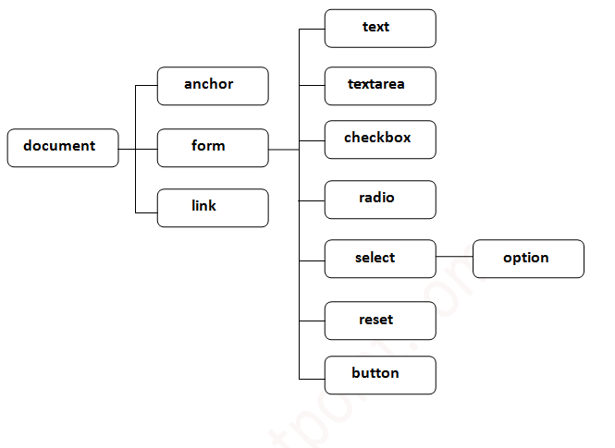

- Methods of document object
We can access and change the contents of document by its methods.
The important methods of document object are as follows:
Method | Description
write("string") | writes the given string on the doucment.
writeln("string") | writes the given string on the doucment with newline character at the end.
getElementById() | returns the element having the given id value.
getElementsByName() | returns all the elements having the given name value.
getElementsByTagName() | returns all the elements having the given tag name.
getElementsByClassName() | returns all the elements having the given class name.

JavaScript Array
JavaScript array is an object that represents a collection of similar type of elements.
There are 3 ways to construct array in JavaScript
- By array literal
- By creating instance of Array directly (using new keyword)
- By using an Array constructor (using new keyword)
1) JavaScript array literal
The syntax of creating array using array literal is given below:
- var arrayname=[value1,value2.....valueN];
As you can see, values are contained inside [ ] and separated by , (comma).
- <script>
- var emp=["Sam","Joseph","John"];
- for (i=0;i<emp.length;i++){
- document.write(emp[i] + "<br/>");
- }
- </script>

2) JavaScript Array directly (new keyword)
The syntax of creating array directly is given below:
- var arrayname=new Array();

3) JavaScript array constructor (new keyword)
Here, you need to create instance of array by passing arguments in constructor so that we don't have to provide value explicitly.
The example of creating object by array constructor is given below.
- <script>
- var emp=new Array("Jai","Vijay","Smith");
- for (i=0;i<emp.length;i++){
- document.write(emp[i] + "<br>");
- }
- </script>

Window Object
The window object represents a window in browser. An object of window is created automatically by the browser.
Window is the object of browser, it is not the object of javascript. The javascript objects are string, array, date etc.

Methods of window object
The important methods of window object are as follows:
Method | Description
alert() | displays the alert box containing message with ok button.
confirm() | displays the confirm dialog box containing message with ok and cancel button.
prompt() | displays a dialog box to get input from the user.
open() | opens the new window.
close() | closes the current window.
setTimeout() | performs action after specified time like calling function, evaluating expressions etc.

What is a JavaScript Object?
Objects in everyday life have properties and “method” actions. Take, for instance, a fan. It's an object with properties such as make, color, or model, and actions it can perform such as cooling rooms and controlling humidity.
As explained above, objects in JavaScript are core data structures that comprise properties and methods. While methods are functions/actions an object can perform (such as driving and cooling rooms with real life objects like cars and fans), properties are characteristics of an object such as its name and value.
Objects let you group related data together and split code into logical pieces. In JavaScript, we have primitive values and reference values. Number, Boolean, Null, Undefined, String, and Symbol are primitive values, while objects like DOM nodes, Arrays, and so on are reference values.

const person = {
name:'kamal',
age:30,
friends:[
'Shola','Ade','Ibraheem'
],
greet:function(){
alert('Hello World')
}
}

How to Modify Properties in an Object

const person = {
name:'kamal',
age:30,
friends:[
'Shola','Ade','Ibraheem'
],
greet:function(){
alert('Hello World')
}
}
person.isAdmin = true;
person.name = 'lawal';
console.log(person);

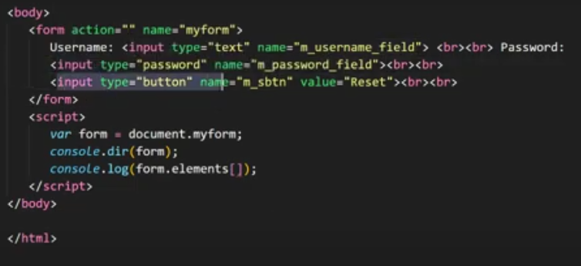

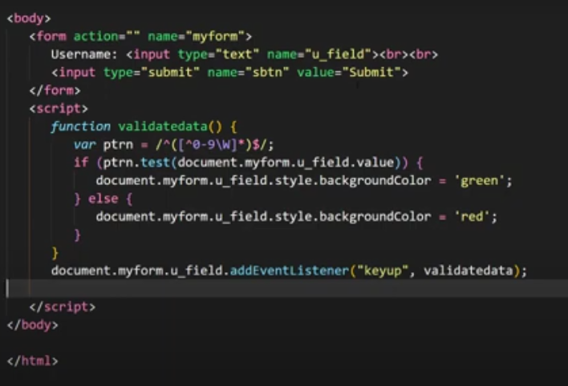

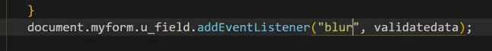
On tab press only it will show user is invalid.

What Is setTimeout?
setTimeout is a Web API provided by browsers (or the Node.js runtime) that lets you schedule a function to run after a specified delay. It doesn’t block the main thread—it just sets a timer and moves on.
setTimeout(() =>
{
console.log("Runs after 2 seconds");
}, 2000);
The setTimeout() function in JavaScript is used to execute a function or evaluate an expression after a specified delay in milliseconds.

// program to display a text using setTimeout method
function greet() {
console.log('Hello world');
}

setTimeout(greet, 3000);
console.log('This message is shown first');
o/p:
Id: 3
Hello world

// program to display a name
function greet(name, lastName) {
console.log('Hello' + ' ' + name + ' ' + lastName);
}

// passing argument to setTimeout
setTimeout(greet, 1000, 'John', 'Doe');

What Is a Callback?
A callback is a function passed as an argument to another function, which is then invoked inside that function to complete some kind of routine or action.
This allows JavaScript to execute code after a task finishes—especially useful in asynchronous operations like API calls, timers, or file reading.
📚 Theory Behind Callbacks
JavaScript is single-threaded, meaning it executes one command at a time. But many tasks (like fetching data or waiting for user input) take time. Instead of blocking the thread, JavaScript uses callbacks to handle these tasks efficiently.
🔄 How It Works:
- You define a function (callback).
- You pass it to another function.
- The other function executes it when appropriate—often after a task is completed.
This is the foundation of event-driven programming in JS.

function greet(name, callback) { //callback= afterGreet
console.log(`Hello, ${name}!`);
callback(); // Call the callback function
}

function afterGreet() {
console.log("Greeting is complete.");
}

greet("Ram", afterGreet);

What is Callback Hell?
Callback Hell in JavaScript can be defined as the situation where we have nested callbacks(functions passed as arguments to other functions) which makes the code difficult to read and debug. The term "callback hell" describes the deep nesting of functions that can result in poor code readability and difficulty in debugging, especially when handling multiple asynchronous operations.
Here's a simple and relatable example of callback hell using setTimeout to simulate asynchronous steps in a food delivery process:
setTimeout(() => {
console.log("Order placed");
setTimeout(() => {
console.log("Restaurant received the order");
setTimeout(() => {
console.log("Preparing food");
setTimeout(() => {
console.log("Food ready");
setTimeout(() => {
console.log("Order delivered");
}, 1000);
}, 1000);
}, 1000);
}, 1000);
}, 1000);

Each step is nested inside the previous one, creating a deep structure:
- Every setTimeout waits 1 second before executing.
- Each step depends on the previous one finishing.
- The code becomes harder to read and maintain as more steps are added.
Downsides of Callback Hell
1. Poor Readability
- Code becomes deeply indented and hard to follow.
- It resembles a pyramid or staircase, making it visually cluttered.
- Understanding the flow requires tracing through multiple nested layers.
2. Difficult Maintenance
- Making changes or adding new logic can break the structure.
- Refactoring becomes risky and error-prone.
- Collaboration suffers when teammates struggle to understand the code.
3. Hard to Debug
- Errors can be buried deep inside nested callbacks.
- Tracing bugs through multiple layers is time-consuming.
- Stack traces may not clearly indicate where the problem originated.
4. Complicated Error Handling
- Each callback needs its own error check.
- Propagating errors up the chain is messy.
- A single missed error handler can cause silent failures.
5. Loss of Sequential Clarity
- Asynchronous execution means the code doesn’t run top-to-bottom.
- Developers must mentally map the execution order, which isn’t always intuitive.
- This can lead to unexpected behavior if dependencies aren’t handled properly.
6. Spaghetti Code
- The structure becomes tangled and chaotic.
- Logic is scattered across nested functions.
- It’s easy to introduce bugs when modifying or extending functionality.

🧹 How to Avoid It
Modern JavaScript offers cleaner alternatives:
- Promises: Flatten the structure and centralize error handling.
- Async/Await: Makes asynchronous code look synchronous.
- Modularization: Break logic into smaller, reusable functions.
Want to see how a messy callback hell example transforms into clean async/await code? I can show you side-by-side.

What Is a Promise?
A Promise is an object representing the eventual completion (or failure) of an asynchronous operation. It has three states:
• Pending: Initial state, neither fulfilled nor rejected.
• Fulfilled: Operation completed successfully.
• Rejected: Operation failed.
You create a Promise like this:
const myPromise = new Promise((resolve, reject) => {
// async operation
if (success) {
resolve("It worked!");
} else {
reject("Something went wrong.");
}
});

What Is .then()?
The .then() method is used to handle the result of a fulfilled Promise. It allows you to specify what should happen when the Promise resolves.
myPromise.then(
(value) => {
console.log("Success:", value);
},
(error) => {
console.log("Error:", error);
}
);
✅ Parameters:
- onFulfilled: A function that runs when the Promise is resolved.
- onRejected (optional): A function that runs when the Promise is rejected. (Though

Chaining with .then()
- One of the most powerful features of .then() is chaining. Each .then() returns a new Promise, allowing you to sequence async operations:
fetchData()
.then((data) => {
return processData(data);
})
.then((processed) => {
return saveData(processed);
})
.then((result) => {
console.log("All done:", result);
})
.catch((err) => {
console.error("Something failed:", err);
});
Destructuring in JavaScript is a powerful feature introduced in ES6 that lets you unpack values from arrays or properties from objects into distinct variables—making your code cleaner, shorter, and easier to read.
Array Destructuring
You can extract values from an array based on their position:
const fruits = ["apple", "banana", "cherry"];
const [first, second] = fruits;

console.log(first); // "apple"
console.log(second); // "banana"

Object Destructuring
You can extract properties from an object by matching keys:

const user = { name: "Alice", age: 25 };
const { name, age } = user;

console.log(name); // "Alice"
console.log(age); // 25

function uploadVideo()
{
setTimeout(()=>
{
console.log(" In Upload Video");
}, 3000);
}
function publishVideo()
{
setTimeout(()=>
{
console.log(" In publish Video");
}, 2000);
}
function notifySubcriber()
{
console.log("In Notify Subbcriber");
}

uploadVideo(publishVideo());
notifySubcriber();

uploadVideo(function(){publishVideo(function(){notifySubscriber();})}

function uploadVideo(callback) //Callback = Publish Video
{
console.log("üploading the video");
setTimeout(()=>
{
console.log(" Upload done");
callback();
}, 3000);
}
function publishVideo(callback) //Callback = NotifySubcriber
{
console.log("Publishing the video");
setTimeout(()=>
{
console.log(" publish Done");
callback();
}, 2000);
}
function notifySubcriber()
{
console.log("In Notify Subbcriber");
}

//uploadVideo(publishVideo());
uploadVideo(function(){
publishVideo(function(){
notifySubcriber();
})
})

